Newsletter
Issue 7 Term 2 Week 4

TERM 2

Week 5

Mon 27/5
Pupil Free Day

Thur 30/5
Grandparents Day

Fri 31/5
Girls SAPSASA Soccer

Week 6

Wed 5/6
World Environment Day
Special Lunch

Fri 7/6
SAPSASA Cross Country

Week 7

Mon 10/6
Public Holiday
Queen’s Birthday

Wed 12/6
Camp Quality
Puppet Show

A Message from the Principal

We have had a busy week 4 at Karrendi! Filled with special moments and new beginnings, it has been wonderful to see so much positivity spread throughout our school community.

Disco
What fantastic discos we had last night! A big thanks to Joseph and our SRC reps for all their hard work and organisation to make the discos so special. As a team, they made a decision to book a DJ and the ‘Amazing Magic Mike’ did a brilliant job engaging people and encouraging them to participate. It was great to see our students having so much fun! Special thanks also to Julie, Colleen, Dianne, Rebecca and Haylee for all their hard work in the canteen during the night. I want to also say a big thank you to our staff who gave up their time to supervise and help out at the discos. Their dedication and commitment to our students and school community is outstanding and very much appreciated.

Community HUB Playgroup
What an amazing first day we had for our Community HUB Playgroup! It was a great turnout – with 13 families and 16 children coming along. Children who came along had a great time engaging in activities including playdough, coloured rice play, ride-ons, bubbles, ball pit, and making a Rainmaker/Rainstick and a Butterfly or Lion. Well done and congratulations to Hayley – our Community HUB Leader – for making the playgroup a vibrant and positive place for our families to enjoy and connect with each other.

Canteen Week
This week we participated in Celebrate Canteen Week. Whilst Celebrate Canteen Week is not being officially promoted in schools in 2019, we really wanted to acknowledge this special week at Karrendi Primary School. Many thanks to Julie, our canteen manager and Rebecca who works in the canteen as a volunteer throughout the year. Students from Room 17 presented Julie with some beautiful thank you presents and a card today.

Growing with Gratitude
On Wednesday we had a special presentation run by the Growing with Gratitude team, who work in conjunction with The Adelaide Crows and Department for Education. The presentation focussed on the “5 Positive Places” of Positive Reflection, and students were able to learn about the different ways they can practice positive reflection in their daily lives.

Regards,
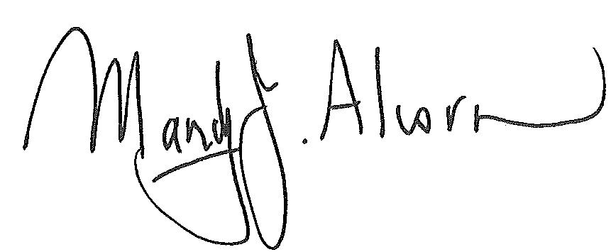
Mandy Alcorn - Principal

Diary Dates

Diary Dates

Bradman Road, Parafield Gardens SA 5107 Phone 08 82583612 Fax 08 82815851 Email dl.1135.info@schools.sa.edu.au www.karrendips.sa.edu.au

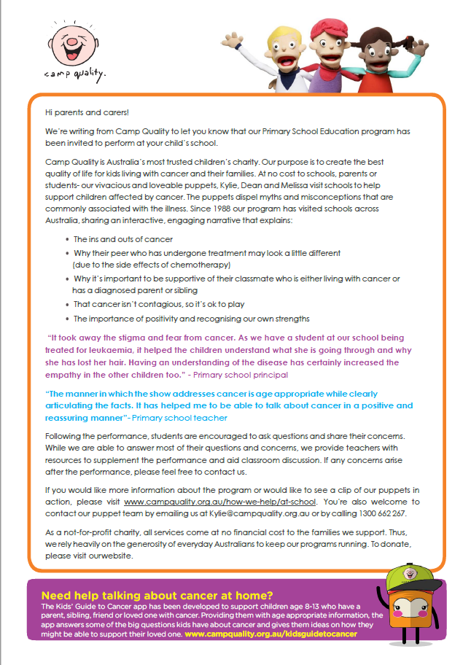
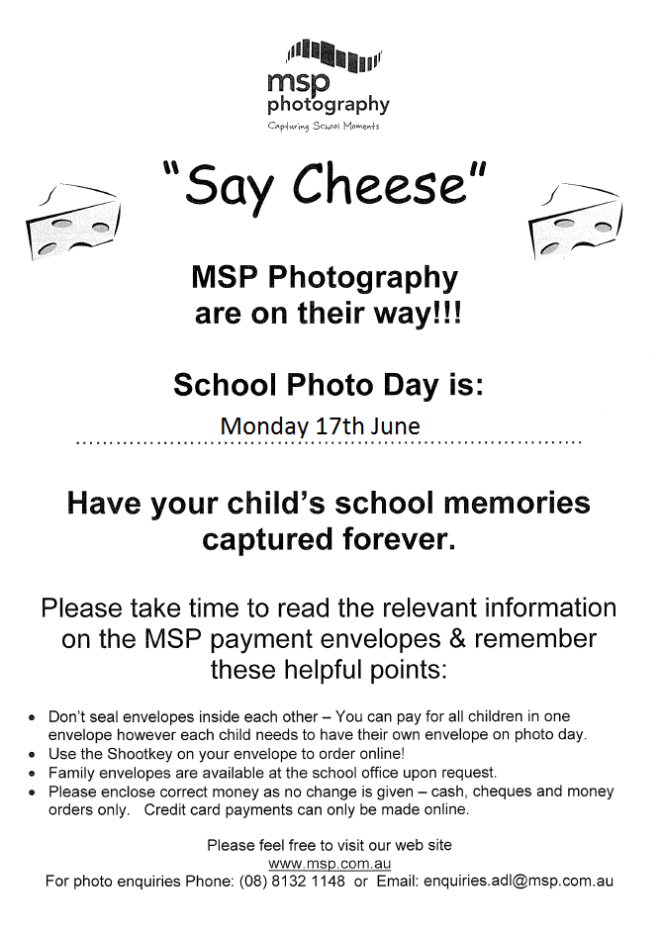
Author Visit – Dr Cameron Stelzer, The Story Doctor
On Monday 17 June, we have a special visit from Author and Illustrator Dr Cameron Stelzer. Dr Cameron is visiting Karrendi Primary School to run workshops with our students. R-3 students will enjoy an interactive Big Screen Book Reading and follow-along drawing activity / inspirational ideas writing session with Cameron. Year 3-7 students will be taking a behind-the-scenes look at creating a book, and applying their own creative components. Students and teachers are looking forward to a great day!
In conjunction with the Author Visit, Karrendi PS families have a special opportunity to purchase signed and personalised copies of Cameron’s books at special prices. Individual books are $15 each and there are also exclusive book sets available. Students will receive an order form on the day of the workshops. Forms and payment can be returned the following day, Tuesday 18 June, to the Front Office.

